# Functions

Specify return type of the function

- void means not gg to return a value

Need to have a void main() function that will run everytime a java program is executed

- will be within a class Main() class

- should always be a static method

Naming convention: camelNamingConvention

# Classes

Functions exist in classes, which contain one or more related functions

Naming convention: PascalNamingConvention

## **Constructors**

- like **__init__** in python

- under the class, have a function with the same name as the class

Overloaded constructors

- multiple constructors within a class w the same name but have diff parameters

- name + parameters = signature

Variable scope

- local: declared inside a method, visible only to the method

- global: declared outside of a method but within a class, visible to all parts of a class

**Inheritance**

public class Car extends Vehicle

- inherit all attributes and methods

Super keyword -- refers to parent class

**Abstract Keyword**

- cannot be instantiated, but can have a subclass

- abstract methods r declared without an implementation

- to prevent someone from creating a class that i too big / abstract

- eg Car is a subclass of Vehicle, Vehicle should be abstract cos its too big

- public abstract class Vehicle

Abstract methods -- cannot have a body eg abstract void go() with no {}

- forces u to implement this method in each of the child classes

# Interface

*Uses of Interfaces in Java are mentioned below:*

* *It is used to achieve total abstraction.*
* *Since java does not support multiple inheritances in the case of class, by using an interface it can achieve multiple inheritances.*
* *Any class can extend only 1 class, but can any class implement an infinite number of interfaces.*
* *It is also used to achieve loose coupling.*
* *Interfaces are used to implement abstraction*

all the methods in an interface are declared with an empty body and are public and all fields are public, static, and final by default. A class that implements an interface must implement all the methods declared in the interface. To implement the interface, use the implements keyword.

# Modifiers

**Access Modifiers**

Determines if other classes and methods can access

- eg public, private

- put in front of class and method declarations public class Main(), public void main()

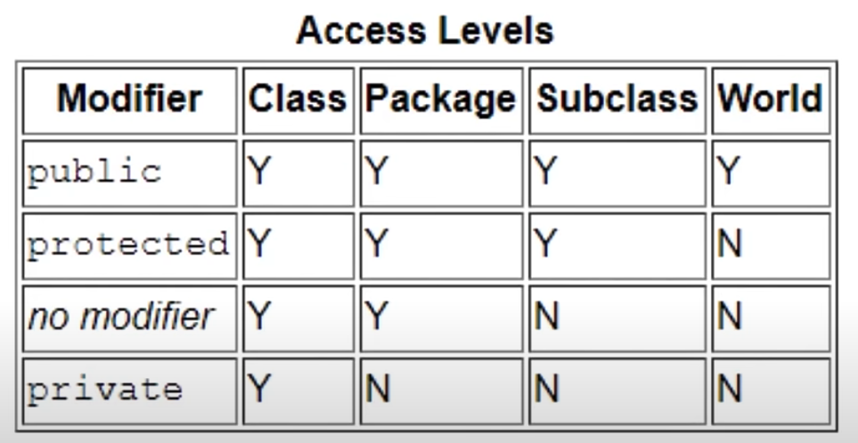

**Static keyword**

- a single copy of a variable / method is created and shared

- the class “owns” the static member (shared by all instances of that class)

# Other stuff

Terminate statements with ;

To change variable names for all, do shift + F6, then hit enter after typing new name

**Types**

# Primitive types:

- dont need to allocate memory

- not an object, so no members

- diff memory locations

- byte x = 1

- byte y = x

- changing x does not change y

- char is one character → single quotes

- strings (which r reference types) → double quotes

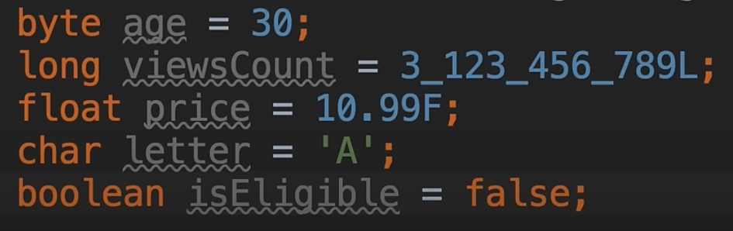

## **Implicit casting**

Byte > short > int > long > float > double

Means can automatically cast from int to float

Else need to

Double x = 1.1

Int y = (int)x + 2 //to cast x as int

## **Convert between incompatible types**

String x = “1”

int y = Integer.parseInt(x) + 2 //to cast x as int

# Reference Types:

- objects, have members

- points to same memory location (cos it stores the memory address instead of the actual value,so when u assign one variable to another, the same address is stored)

- need to assign memory to it so Date today = **new** Date();

Arrays (fixed length)

- int[] numbers = new int[5]; // here 5 is the length of the array

- numbers[0] = 1

- if u dont assign numbers, default is

Int: 0

String: empty string

Bool: false

Another way to initialize

- int[] numbers = {1,2,3,4,5}

For variable length → need to use collection class

Use Arrays class to sort, print

Multi dimensional Arrays

Int[][] numbers = new int[2][3] // means 2 rows 3 cols

**Constants**

final pi = 3.14F // the final means cannot change this value

Arithmetic operations

int result = (double)10 / (double)3 // here casting 10 and 3 as doubles, but give error

double result = (double)10 / (double)3 // no error

# Operators

**Comparison operators**

Int x = 1;

Int y = 1;

Boolean expressions

X == y // true

X != y // false

**Logical operators (left to right)**

AND: &&

OR: ||

NOT: !

Tenery operator

String className = income > 100_000 ? “First” : “Economy”

- means if income more than 100000, className = “First”, else is “Economy”

# Conditional

if (boolean expression) {

Do something here;

}

else if (bool expression) {

Do something;

}

else {

Do something;

}

- can only declare variable in code blocks (must be curly braces)

- variables declared in if block cannot be accessed outside of the block that its declared in (to resolve this just declare this outside)

- can just String className; // to declare a variable

switch (role) {

case “admin”: // if role == “admin”

Do something

Break

default:

Do something

// dont need break statement

}